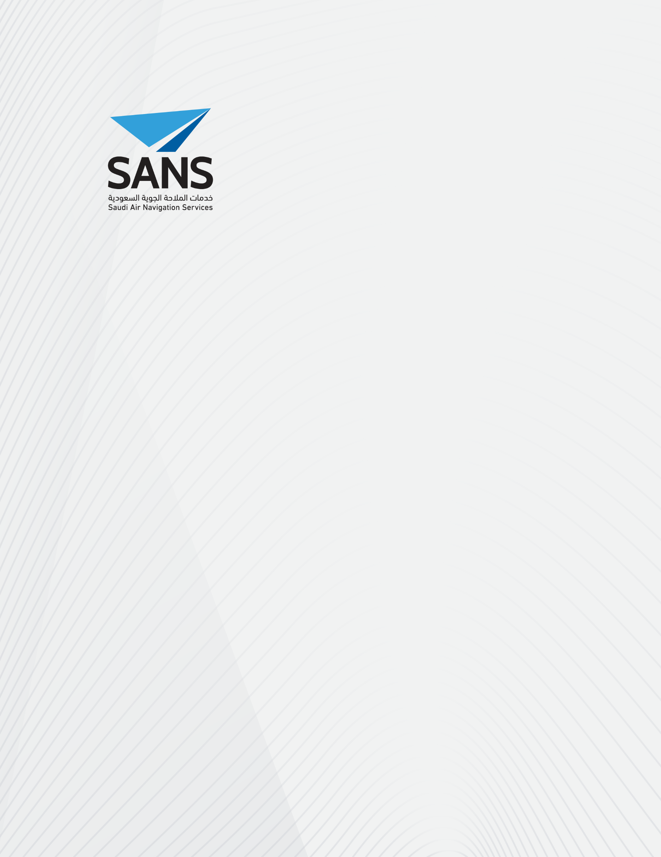SQE

**Quality Management System**

**Safety Management System Manual**

***Initial Safety Impact Assessment***

**[Insert Report Title Here]**

**Document Control: To view the latest version of this document, please refer to SANS Portal. This document remains controlled unless downloaded or copied. For any inquiries or change requests, please approach SQC.**

Document Information

|  |  |
| --- | --- |
| **Document title** |  |
| **Document reference** |  |
| **Document author** |  |
| **Version number** |  |
| **Version date** |  |
| **Status** |  |
| **Notes** |  |

Change Record

|  |  |  |  |  |  |
| --- | --- | --- | --- | --- | --- |
| **Version** | **Date** | **Author** | **Change Description** | **Reviewed by** | **Effective Date** |
|  |  |  |  |  |  |

Document Approval

|  |  |  |  |
| --- | --- | --- | --- |
| **Authored by** | | | |
| *Insert Date* | *Insert Name* | *Insert Position* | *Insert Signature* |
| **Reviewed by** | | | |
| *Insert Date* | *Insert Name* | *Insert Position* | *Insert Signature* |
| **Risk accepted by[1]** | | | |
| *Insert Date* | *Insert Name* | *Insert Position* | *Insert Signature* |
| **Approved by** | | | |
| *Insert Date* | *Insert Name* | *Insert Position* | *Insert Signature* |
| **Endorsed by1** | | | |
| *Insert Date* | *Insert Name* | *Insert Position* | *Insert Signature* |

1. Assessment Summary

This document contains the initial Safety Impact Assessment for <Proposed Change>. The assessment has been conducted as per the Process:

*SANS-SQE-PMM02-P08-Assess Safety Impact of Change Process and Procedure*

This assessment is completed and documented in 5 parts:

* **Change Summary**

This contains the summarised details of the proposed change. This has been used to assess the initial safety impact as per the following Parts of the document.

* **Part A – Safety Impact**

Part A reviews the proposed change to determine whether the change to be introduced has any safety impact on SANS operations and the wider community.

For this assessment of the <Proposed Change>, it was determined that there **<is a / is no>** safety impact as a result of the change.

* **Part B – Safety Significance**

Part B of this document is only completed if it is determined in Part A that the proposed change will impact safety of SANS operations.

For Part B, the proposed change is reviewed to determine the significance that the proposed change will affect SANS operations (i.e. the level of impact).

For this assessment of the <Proposed Change>, it was determined that the safety significance of change is considered **<High / Medium / Low>.** Therefore, as per the process, a **<Project Safety Case / Safety Risk Assessment / Part C - Safety Risk Assessment** **for ‘Low’ Safety Significance Changes>** will be completed for this change.

* **Part C – Safety Risk Assessment for ‘Low’ Safety Significance Change**

Part C of this document is only completed if it is determined that the safety impact is ‘Low’ Safety Significance which **do not** require a full Safety Risk Assessment.

The safety risk assessment for the ‘Low’ Significance Changes is contained within this document.

For this initial safety impact assessment of the <Proposed Change>, as the safety significance was determined to be:

* **<High>**, the risk assessment will be conducted as part of the SANS-SQE-PMM02-P10-Develop Project Safety Case for Changes Process and Procedure;
* **<Medium>**, the risk assessment will be conducted as part of the SANS-SQE-PMM09-P08-Conduct Safety Risk Assessment Process and Procedure;
* **<Low>**, the risk assessment will be conducted in Part C of this form.
* **Part D – Notification to GACA**

Part D of this document is completed to determine if the change require notification to GACA.

1. Change Summary

*The following table should be completed to briefly describe the change in enough details to support this assessment.*

|  |  |
| --- | --- |
| **Change ID:[2]** |  |
| **Proposed Change Description:** | |
| *Provide description of the change to be implemented.* | |
| **Scope of the Change:** | |
| *Provide a brief overview of the scope of the assessment. I.e. what service, or change to service, the assessment covers and the boundaries, or the scope of a proposed change to the Service including the effect of the change on the fatigue related factors.* | |
| **Change Plan:** | |
| *Describe the steps of the change to be implemented, including:*   * *What are the specific activities* * *When will it be performed* * *By who*  |  |  |  |  | | --- | --- | --- | --- | | *Activity* | *Performed by* | *Start* | *End* | |  |  |  |  | | |

1. Part A – Safety Impact

*The following table should be completed as per the guidance contained within SANS-SQE-PMM02-P08-Assess Safety Impact of Change Process and Procedure.*

|  |  |  |  |
| --- | --- | --- | --- |
| **Proposed Change** | | **Yes / No** | **Justification** |
| 1 | Does the change introduce a new service? |  |  |
| 2 | Does the change modify what the service provides to a customer (e.g. airspace users for ATM services or ATCO for Technical Services)? |  |  |
| 3 | Does it change how the service is provided or impact an existing safety control? |  |  |
| 4 | Does the change introduce potential new failure modes or causal factors? |  |  |
| 5 | Does it change a system element (people, procedures or equipment) that is recognised as a mitigation? |  |  |
| 6 | Does the change impact/introduce relevant cyber security threats or internal and external vulnerabilities? |  |  |
| 7 | Does the change impact any work-related fatigue factors? |  |  |
| 8 | Does the change include operational or technical activities which might have impact on the live service? |  |  |
|  | | | |
| **Based on the above, is there a safety impact as a result of this change?** | | |  |

1. Part B – Safety Significance

*The following table should be completed as per the guidance contained within SANS-SQE-PMM02-P08-Assess Safety Impact of Change Process and Procedure*

|  |  |
| --- | --- |
| **Change Criteria** | |
| **High** | * What the service provides to an internal or external customer is significantly modified i.e. a change to concept; * Change affects services at multiple sites. * Novel Functionality is to be provided. * New instrument flight procedure concepts introduced. |
| **Medium** | * Change does not implement new functionality, but it changes the operator’s Human Machine Interface (HMI). * Change affects a single service at a single site. * Change is high significance but has been implemented before at another site. * Change has the potential to undermine the accuracy of the data provided. * New Cyber Security Control with significant change which requires system re-design is implemented; * Changes affects more than two work-related fatigue factors. |
| **Low** | * It is an update to operational and technical procedures/documentation. * It is a hardware refresh. * It is installation of support system (Batteries, UPS, Generator, …) without direct effect on the main system. * It is a software upgrade without functional change. * It is an update to an existing cyber-security control, or a new cyber security control is implemented with no significant change. * It is a routine change that have been performed many times or are planned to be performed many times and procedures are in place to manage this type of change. |
|  | |
| **Level of assessment required?** | *High – Project Safety Case*  *Medium – Safety Risk Assessment*  *Low – ‘Light Safety Risk Assessment’ – Refer to Part C.* |

1. Part C – Safety Risk Assessment for ‘Low’ Safety Significance Changes

*The following table should be completed as per the guidance contained within SANS-SQE-PMM02-P08-Assess Safety Impact of Change Process and Procedure. This is for* ***Low*** *safety significance changes only.*

C.1 Hazard Assessment

|  |  |  |  |  |  |  |  |  |  |
| --- | --- | --- | --- | --- | --- | --- | --- | --- | --- |
| **Hazard ID** | **Hazard Description** | **Consequence** | **Severity**  **(Initial)** | **Likelihood**  **(Initial)** | **Risk Class**  **(Initial)** | **Mitigation** | **Severity**  **(Post Mitigation)** | **Likelihood**  **(Post Mitigation)** | **Risk Class**  **(Post Mitigation)** |
| Hz-01….. |  |  |  |  |  |  |  |  |  |
|  |  |  |  |  |  |  |  |  |  |
|  |  |  |  |  |  |  |  |  |  |
|  |  |  |  |  |  |  |  |  |  |
|  |  |  |  |  |  |  |  |  |  |

C.2 Safety Requirements

The Safety Requirements identified within the Part C Safety Risk Assessment are re-produced here and include the allocated owner of the Safety Requirement.

*The Safety Requirements are managed through the Safety Requirements Implementation Plan which should be created for each Part C Safety Risk Assessment. For this, refer to SANS-SQE-PMM02-FO24-Safety Requirement Implementation Plan Form.*

| **SR Id** | **Safety Requirement** | **Source**  **(Related Hazard)** | **Safety Requirement Owner** | **Status** |
| --- | --- | --- | --- | --- |
| SR01-… |  |  |  |  |
|  |  |  |  |  |
|  |  |  |  |  |
|  |  |  |  |  |
|  |  |  |  |  |
|  |  |  |  |  |

1. Part D – Notification to GACA

*The following table should be completed as per the guidance contained within SANS-SQE-PMM02-P08-Assess Safety Impact of Change Process and Procedure.*

|  |  |  |  |
| --- | --- | --- | --- |
| **Proposed Change** | | **Yes / No** | **Justification** |
| 1 | Does the change introduce additional locations for providing the air navigation services? |  |  |
| 2 | Does the change affect any designated SANS personnel as specified in the Operations Specifications? |  |  |
| 3 | Does the change affect any facility, procedure, system, work scope or staff that are used for the provision of air navigation services? |  |  |
| 4 | Is the change associated with SANS Operations Specifications (require update of the SANS Operations Specifications for example)? |  |  |
|  | | | |
| **Based on the above, does the change require notification to GACA prior implementation?** | | |  |

1. Applicable only for Change with **LOW** Safety Significance. For changes with no safety impact or **Medium** or **High** safety significance, those rows shall be deleted.
2. As per the Safety Change Log